YABUT, ROMAFE P. FEB 07, 2025

BSCpE-3A CpE 165 2B

**CHAPTER 1: RELATIONAL DATABASE CONCEPTS**

**Laboratory Activity 1:**

**Laboratory Title:** Installing MySQL and Setting Up the Database  
**Chapter No. and Topic:** Chapter 1 - Relational Database Concepts

**Activity Description:**  
Install MySQL, create a new database, and establish connections using MySQL Workbench or command line.

**Result:**  
A running MySQL instance with a database called LibraryManagement.

**Additional Questions/Discussions:**

* Why is MySQL popular for DBMS?

*MySQL is popular because it’s an open-source database management system, which means it’s free to use and easy to access. It’s reliable and has been used by many large companies and organizations for years. MySQL also offers good performance, especially with large amounts of data or when there are many people accessing the database at the same time. It’s also compatible with multiple operating systems like Windows, Linux, and macOS, and works well with many programming languages, like PHP, Java, and Python. Plus, since it’s so widely used, there’s a huge community with plenty of resources and support.*

* What are the advantages of using MySQL for a library management system?

*MySQL is an excellent choice for a Library Management System due to its scalability, data integrity, security, ease of use, cost-effectiveness, and strong community support, making it a reliable and efficient solution for managing library data.*

**Conclusions:**

*In this lab, I learned how to install MySQL and create a database for a Library Management System. By following the steps to set up MySQL and connect to it, i got practical experience in working with databases. I also saw how MySQL can be useful for organizing and managing data in systems like a library. This lab helped me understand the basics of using MySQL and how it can help with tasks like keeping data safe, easy to access, and organized. Now, i have a better idea of how to use MySQL for real-world applications.*

YABUT, ROMAFE P. FEB 07, 2025

BSCpE-3A CpE 165 2B

**Laboratory Activity 2:**

**Laboratory Title**: Creating Tables and Establishing Primary Keys

**Chapter No. and Topic: Chapter 1** - Relational Database Concepts

**Discussions:** This activity focuses on creating the main tables for the Library Management System, with primary keys for each table.

**Activity Description:**

Create tables such as Books, Members, and Transactions for the library system.

**Result:**  
Three tables (Books, Members, and Transactions) are created.

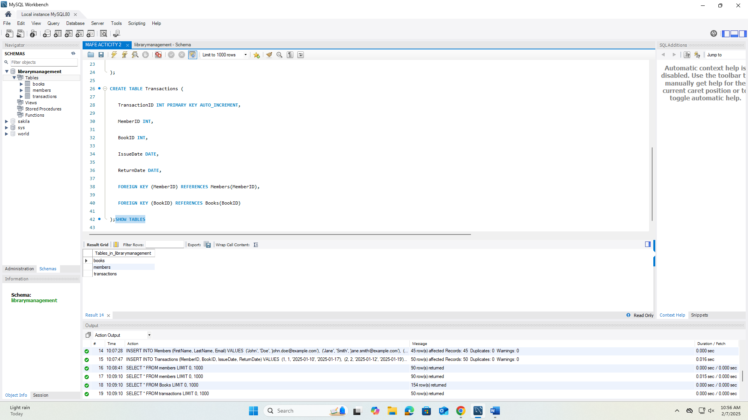

**INSERT DATA**

**Additional Questions/Discussions:**

* What is the importance of primary keys in a relational database?

*Primary keys are essential because they uniquely identify each record in a table, ensuring no two rows are identical. This is critical for maintaining data integrity and prevent duplicate data.*

* How do foreign keys maintain referential integrity?

*Foreign keys establish relationships between tables by linking records from one table to another. This ensures that data across tables remains consistent. For example, in our Transactions table, the foreign keys for MemberID and BookID ensure that transactions are only linked to existing members and books.*

**Conclusions:**

*In this laboratory activity, we successfully created essential components of a library management system by establishing tables for books, members, and transactions, and ensuring proper data organization through primary and foreign keys. The use of* ***primary keys*** *ensures that each record within a table is unique, which is essential for maintaining accurate and non-redundant data. By incorporating* ***foreign keys****, we linked related data across different tables, ensuring the integrity of our database and facilitating seamless relationships between books, members, and transactions.*

YABUT, ROMAFE P. FEB 07, 2025

BSCpE-3A CpE 165 2B

**CHAPTER 2: STRUCTURED QUERY LANGUAGE (SQL)**

**Laboratory Activity 3:**

**Laboratory Title:** Structured Query Language (SQL) - Basic Queries  
**Chapter No. and Topic:** Chapter 2 - Structured Query Language (SQL)  
**Discussions:**  
This activity covers the basics of querying data from a table using SQL.

**Activity Description:**  
Learn how to retrieve data using SELECT, filter with WHERE clauses, and sort results using ORDER BY.

**Result:**  
Basic queries to retrieve and filter data from the Books table.

**Additional Questions/Discussions:**

* How do WHERE and ORDER BY improve the functionality of SQL queries?

*Together, the WHERE and ORDER BY clauses improve SQL queries by making data retrieval more targeted and organized. These clauses allow users to retrieve specific data efficiently and display it in a way that suits their needs, thus optimizing query performance and readability.*

**Conclusions:**

*In this laboratory activity, we explored the basics of Structured Query Language (SQL) and learned about how to retrieve and manipulate data from a table using simple queries. I practiced using the SELECT statement to pull data from the Books table, applied filters with the WHERE clause to retrieve specific records, and sorted the results using the ORDER BY clause.*

*Using the WHERE clause helped us filter data based on specific conditions, allowing us to narrow down the results, such as retrieving only books of a certain genre. The ORDER BY clause, on the other hand, enabled us to sort the data in a meaningful way, such as arranging the books alphabetically by their title.*

YABUT, ROMAFE P. FEB 07, 2025

BSCpE-3A CpE 165 2B

**Laboratory Activity 4:**

**Laboratory Title:** SQL - JOIN Operation  
**Chapter No. and Topic:** Chapter 2 - Structured Query Language (SQL)  
**Discussions:**  
This activity introduces students to SQL JOIN operations for combining data from multiple tables.

**Activity Description:**  
Learn how to use INNER JOIN, LEFT JOIN, and RIGHT JOIN to combine tables.

**Result:**  
JOIN operations linking tables to retrieve combined data.

**Additional Questions/Discussions:**

* How does the LEFT JOIN differ from the INNER JOIN?

*In summary,* ***INNER JOIN*** *filters out rows that don't have matches in both tables, while* ***LEFT JOIN*** *ensures that all rows from the left table are returned, even if there's no match in the right table.*

**Conclusions:**

*SQL JOIN operations, including INNER JOIN, LEFT JOIN, and RIGHT JOIN, play a crucial role in extracting and combining data from multiple tables in relational databases. These operations enable users to construct more complex and meaningful queries, ensuring that data is retrieved in a way that reflects the relationships between tables. The INNER JOIN returns only matching rows, making it useful when you need data present in both tables, while the LEFT JOIN ensures all records from the left table are included, even if no corresponding records exist in the right table. Mastering these JOIN techniques allows users to generate comprehensive insights and create a more holistic view of the database, thus improving data analysis and decision-making processes*.